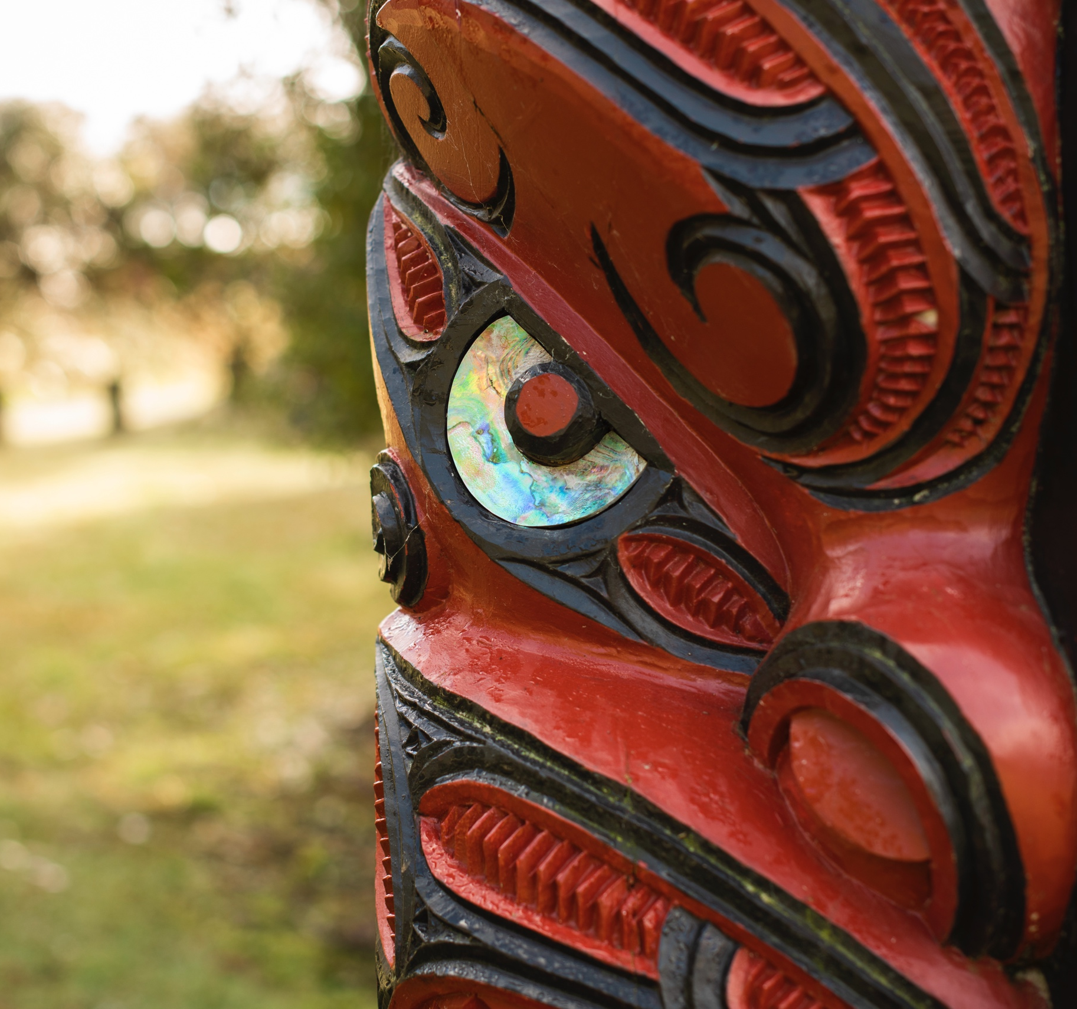

He Rautaki Taonga Tuku Iho

Cultural Monitoring Protocol
s
Contents

He Rautaki Taonga Tuku Iho
Cultural Monitoring Protocol
Timatanga kōrero - Introduction 3
Purpose of cultural monitoring 5
Relationships 6
Remuneration 6
When to use cultural monitors 6
Cultural Monitoring Process 7
Roles 7
Monitoring 8
Responsibilities 12
Disputes 13
Signed 13
Asssociated plans/policies 14

Timatanga kōrero - Introduction

He Rauru – Council’s kaupapa Māori framework outlines our commitment to strengthening partnerships with Tangata Whenua and enabling Mana Motuhake through equity and shared decision making. This approach is also reflected in one of Council’s community outcomes which says we will have authentic Te Tiriti based relationships with Tangata Whenua as well as one of our strategic priorities which commits to growing authentic Te Tiriti based relationships.

There is a lot that underpins Council’s approach to working with Māori – Māori are a party to Te Tiriti o Waitangi together with the Crown, and there are statutory obligations we have to Māori perspectives and their knowledge systems. In addition to this, iwi and hapū have social, economic and environmental aims based on the Te Ao Māori worldview articulated in settlement legislation and iwi/hapū management plans. This makes Tangata Whenua a key partner for Council and the work we do with.

He Rauru contains some rich kōrero from Tangata Whenua in our district. Kōrero about their history, their aspirations, their experiences, and their expectations when it comes to working with us. It should always be a point of reference for the work that we do with Tangata Whenua. Make sure you check it out on Westworld.

He Rautaki Taonga Tuku Iho – Cultural Monitoring Protocol provides the means for Council to work with Tangata Whenua on:

- The protection of sites of valuable historic heritage.
- A process for dealing with the discovery of Koiwi Tangata (human skeletal remains) and Taoinga Tuture (artefacts).

NOTE:
Please replace highlighted sections with the relevant information

We acknowledge that staff will need support to meet our commitments to Tangata Whenua. Training and capacity building provided under the korowai of He Rauru will provide the means to do so. A few examples are –

- Engagement wānanga working through how to apply this guide in practice.
- Te Tiriti o Waitangi wānanga.
- Staff participation in the Wall Walk.


Purpose of cultural monitoring

This agreement provides Western Bay of Plenty District Council (Council) and [Name of relevant iwi/hapū], with a framework for ensuring the protection of sites of valuable historic heritage, Koiwi Tangata (human skeletal remains) and Taonga Tuturu (artefacts) during earthworks associated with [Project name].
The Partners are committed to engaging and working in the spirit of good- faith and cooperation based on the relationship principles listed below for the duration of the Project.
Mana
Recognition and respect of the mana and authority of those operating under this protocol.

Whakapono
Acting with integrity, respect and being open and transparent.

Whanaungatanga
Fostering meaningful relationships and being respectful of different
perspectives.

Kōrero ā kanohi
Engaging on issues face to face; being upfront and honest.

Rangatira ki te Rangatira
Recognising respective leaders and involving key decision makers
where and when appropriate.

Kaitiakitanga and Te Ao Māori
Providing for kaitiakitanga; valuing mātauranga Māori; integrating Tikanga and Te Reo Māori where appropriate.

Kotahitanga
Meeting agreed milestones; seeking solutions and looking for ways to mitigate challenges.

Mana whenua
Recognising the mana of iwi and hapū who practice ahi kaa in their rohe (tribal boundaries). Ahi kaa signifies that an iwi/hapū has a permanent presence in a rohe and has continuously worked to meet their obligations as the holders of mana in that area.

Relationships

The parties acknowledge the importance of building and maintaining enduring relationships to give effect to this agreement. The Treaty landscape has elevated the importance of Tangata Whenua and their relationship to Te Ao Māori (Māori worldview), Te Ao Wairua (the spiritual realm) and Te Taiao (physical and natural environment). Recent Resource Management Act reforms provide impetus for Councils to enhance Tangata Whenua participation in Resource Management Act decision- making processes. Aside from legal responsibilities to Māori, there is a collective aspiration to do the right thing.

Project representatives | Mandated representative
Hapū/Iwi name | Rep name
Council | Authorised representative
Contractor name | Representative name
Project Manager name

Remuneration

Iwi/hapū shall be remunerated at a rate that is fair and equitable and consistent in accordance with He Rauemi – Tangata Whenua Remuneration Protocol

When to use cultural monitors

- When it is a justifiable recommendation in a cultural impact assessment (CIA); or
- When it is a condition of a consent e.g. if there are known significant
- sites; or
- When earthworks are within 100 metres of a registered archaeological site or a site of significance; or
- Upon the recommendation of a qualified archaeologist who is familiar with the area where the earthworks shall be carried out; or
- Upon justifiable recommendations from the hapū as a result of pre planning with mandated representatives of the iwi, hapū or runanga entity or from the relevant iwi/hapū Management Plan; or
- If during the course of the project, accidental discovery identifies that cultural monitoring needs to be undertaken;

Only one of the above conditions may prompt the need for a cultural monitor, however in many cases, a number of these conditions will apply.

Cultural Monitoring Process

Roles

Iwi/Hapū representative(s) | Contact person(s) for the relevant marae, usually responsible for resource management matters.
Project manager | Contact person responsible for  managing the earthworks project, usually a Council staff member or  contractor.
Contractor | Person(s) responsible for  undertaking earthworks project.

Cultural Monitor
The Cultural Monitor will be appointed by the relevant iwi/hapū and their role on site is as Kaitiaki i.e. guardians of ‘Te Ao Māori‘. As Kaitiaki their duty is to observe activities which affect their culture. They will make observations of earthworks, in particular top soil stripping and environmental observations.

Project Manager
The Project Manager will be determined by Council or its contractor. They will confirm details of the earthworks to be undertaken including project scope/details, location, number of work faces and timeframes. The Project Manager and the iwi/hapū representatives will agree the terms and timeframes for cultural monitoring including the number of cultural monitors required by reference to the nature and scale of the Project as well as the risk of uncovering an archaeological find.

The Project Manager will endeavour to notify the Cultural Monitor if work will not be occurring the day prior. However, if the Cultural Monitor has not been notified and is on site or if it is decided work on site cannot be carried out for any reason (i.e. bad weather or breakdown of machinery) then the Cultural Monitor will be paid for the equivalent of two (2) hours work.

Contractor
The Contractor will ensure that ten (10) working days notice is given to the relevant iwi/hapū prior to the commencement of excavations. The iwi/hapū will be responsible for the attendance of the Cultural Monitor.

The Cultural Monitor is to record daily their start and finish times when they are on site and record what was observed. The Contractor shall sign time sheets on a weekly basis. This information is to be supplied and included with any claim for payment.

Project Archaeologist
The Project Archaeologist is responsible for fulfilling his or her obligations in the event of discovery of Koiwi Tangata or Taonga Tuturu in accordance with the conditions of any Heritage New Zealand Authority and more generally in accordance with the Heritage New Zealand Pouhere Taonga Act 2014 and the Protected Objects Act 1975.

Monitoring

Areas of special interest
A plan may be prepared by the mandated iwi/hapū representatives outlining areas of special/cultural interests. Prior to commencing earthworks the Cultural Monitor may identify to all persons on the site:
(a) Where there are culturally sensitive areas (if known);
(b) Provide pre-works induction if necessary;
(c) iwi/hapū specific requirements (if any).

Archaeology
The level of monitoring undertaken by the iwi/hapū (and the number of cultural monitors required for the Project) will reflect the risk of uncovering archaeological evidence. Areas of special interest will require a more intensive level of monitoring, whereas deep excavations in low risk will only need low levels of monitoring.

Whakanoa
Before earthworks commence the iwi/hapū will agree a kaumatua to carry out a whakanoa ceremony for the removal of tapu. The Contractor and kaumatua will liaise prior to any work proceeding. Should Koiwi Tangata or any significant archaeological discovery be uncovered during the Project then iwi/hapū have the right to request a whakanoa ceremony and shall again agree a kaumatua for this purpose.

Discovery of Taonga Tuturu
Immediately following any discovery, the Contractor will cease all excavations and comply with any and all relevant protocols, plans (including iwi/hapū management plans, treaty settlement provisions or relevant Court directions), as well as consent conditions and authorisations from:

- Heritage New Zealand,
- Western Bay of Plenty District Council,
- Bay of Plenty Regional Council.

The Contractor shall immediately advise the Project Manager of any
find who will immediately advise:

- The engineer to the contract,
- Council representatives,
- Iwi/hapū representatives,
- The Project Archaeologist,
- Heritage New Zealand.

Work in the immediate vicinity of the find may only resume with the approval of the Project Archaeologist monitoring the site in consultation with the Cultural Monitor. Initially the Project Archaeologist will have control of and responsibility for any Taonga Tuturu recovered from the site. The Protected Objects Act 1975 details the procedures relating to determining ownership of any Taonga Tuturu discovered.

The Project Archaeologist will record the archaeological materials and any artefacts and will notify the Ministry for Culture and Heritage on the prescribed form of the finding of any Taonga within twenty- eight (28) days of the completion of the fieldwork.

In the event of the discovery of Taonga Tuturu the Tauranga Heritage Collection is the legal repository for the region in regards to fulfilling the requirements of the Protected Objects Act 1975, under the Ministry of Culture and Heritage. This responsibility requires the Tauranga Heritage Collection to store and maintain newly found items recovered from controlled excavation and fieldwork throughout the Western Bay of Plenty sub- region on behalf of the Ministry until the Ministry has been able to determine custodianship.

If there is an opportunity for iwi/hapū to apply to be a legal repository under the Protected Objects Act 1975, the iwi/hapū reserves the right to apply for that status and if granted will be the legal repository for the purposes of these protocols.

Securing a Find Site ‘the immediate vicinity”
Should a find be unearthed, the find site and immediate vicinity around a discovery shall be made secure. The area of the immediate vicinity will be defined by the Contractor, Project Archaeologist and Cultural Monitor and will include any area considered to have high probability of containing archaeological features similar to those found at the discovery site, and that warrant careful investigation. The immediate vicinity may also include an area the Contractor determines is necessary as a safety buffer zone separating those investigating or retrieving archaeological features or material and those carrying out other construction activities, to provide an acceptable level of safety to all persons, and to the features or materials. The Contractor will then take steps to make safe and secure the immediate vicinity including using stakes and tape to restrict access to the find site.

To improve security of the find, or access to the find, the Contractor will assist with any reasonable requests made by the Cultural Monitor.

The Project Archaeologist in accordance with the Heritage New Zealand Pouhere Taonga Act 2014 will record all archaeological information. A copy of the report shall be given to the iwi/hapū within six months (6) of project completion and within two months (2) a summary of the report be presented to the iwi/hapū by the Project Archaeologist. Council will pay for the cost of this work.

Discovery of Koiwi Tangata
If skeletal remains (Koiwi Tangata) are uncovered, then the site is an archaeological site in terms of the Heritage New Zealand Pouhere Taonga Act 2014 and the relevant provisions of that act will apply.

The site and features along with Koiwi Tangata contained within them will be treated in accordance with the conditions of the relevant Heritage New Zealand authority to disturb, modify, or destroy the site. If no such authority exists at the time of the discovery, then one shall be obtained before the site is further modified.

Immediately upon discovery of any Koiwi Tangata, the Contractor will cease all excavation of:

- that “Area of Special Interest”, or
- within “the immediate vicinity” of the find.

The Contractor shall immediately advise the Project Manager who will immediately advise the following:

- The engineer to the contract.
- Council representatives.
- Project Archaeologist.
- Iwi/hapū representatives.
- Heritage New Zealand.
- Ministry of Health
- The New Zealand Police (Māori Liaison)

This is a requirement of Section 14 of the Coroners Act 2006. The Police will report the findings to the nearest coroner in accordance with Section 20 of the Coroners Act 2006 to “give any directions the Coroner thinks fit about removal of a body”. Section 42 of the Coroners Act 2006 empowers the Coroner to release the body to family members.

Within four hours of notice being given by the Contractor to the nominated Iwi/hapū representatives of Koiwi Tangata having been discovered, the nominated iwi/hapū representative will respond to the Contractor on how to proceed. Any cultural ceremonies that are needed will be completed within twenty-four (24) hours of the notice being given to the nominated iwi/hapū representative.

The Iwi/hapū will carry out the appropriate cultural ceremonies at the site. Once these ceremonies are completed, the Project Archaeologist, in consultation with Police and the Iwi/hapū will first inspect the Koiwi Tangata to determine their likely age and then recover them. The Police and/or the Coroner will be responsible for any remains that they take for testing. The Iwi/hapū will liaise directly with the Police and/or Coroner regarding what will happen to the remains once any pathology tests are completed.

Provided there are no conditions in the relevant Heritage New Zealand authority to the contrary, and that the Police and Coroner have no objection, the Iwi/hapū will collectively determine what will happen to the Koiwi Tangata and where they will be reburied, should they wish to do so. One of the Iwi representatives will communicate their decision to the Project Manager.

The Project Archaeologist will record details of the Koiwi Tangata burial only if the Iwi/hapū wishes this to occur. Any records made will be held in accordance with the wishes of the Iwi/hapū. A rahui will prevail between the time of the initial discovery of human remains and 24 hours after the remains have been removed either by the Police or by the Iwi/hapū. During this time, all excavations of the “Area of Special Interest” will cease unless the nominated representatives of the Iwi/hapū advise otherwise.

In the unlikely event, that Iwi/hapū do not respond to the notice of the discovery within 24 hours the Council may proceed with the investigation recovery and reburial of the remains in consultation with the Project Archaeologist, the Coroner, Police, and Heritage New Zealand. In these circumstances, excavations of Areas of Special Interest may resume once the remains have been removed from the site. The Project Archaeologist in accordance with the Heritage New Zealand Pouhere Taonga Act 2014 will record all archaeological information.

Responsibilities

Project Manager
The Project Manager is responsible for:
- Ensuring the provision of personal protective equipment (high visual vests, hard hats and wet weather gear) for the Cultural Monitor;
- The Contractor (and all other relevant site staff) being aware of the
role of the Cultural Monitor;
- Ensuring that the Cultural Monitor is provided with a comprehensive site health and safety induction and conforms to the requirements;
- The observance of the cultural and discovery guidelines included within these protocols;
- The observance of the archaeological authority;
- Payment of invoices rendered by the mandated Iwi/hapū
representatives/ Cultural Monitor.

Iwi/hapū representatives
Are responsible for ensuring:
- That appropriate mandate is in place to operate under these protocols
- That the Cultural Monitor is appropriately trained to be able to
competently undertake the role;
- That the Cultural Monitor is provided with a suitable pair of steel
capped boots
- Invoices are prepared as required;
- Whakanoa are arranged as required and appropriate
tikanga/kawa observed;
- Incoming payments from Council are processed and Cultural Monitor paid;

Cultural Monitor
The Cultural Monitor is responsible for:
- Monitoring on site earthworks to ensure cultural protection occurs;
- Working closely with the Project Archaeologist and Contractor;
- Complying with all health and safety requirements while on site;
- Understanding the Heritage New Zealand archaeological authority
conditions;
- Observing and implementing on behalf of their respective iwi/hapū, where required, the cultural and discovery guidelines included within this agreement.

Note: the Cultural Monitor shall be answerable to the Project Manager while on site.

Contractor
The Contractor is responsible for adhering to:
- The cultural and discovery guidelines included within this agreement;
- All site health and safety requirements;
- Conditions of any Heritage New Zealand archaeological authority;

Heritage New Zealand
Heritage New Zealand is responsible for fulfilling its statutory obligations in the event of the discovery of Koiwi Tangata and/or Taonga Tuturu, as appropriate.

Disputes

Any cultural disputes between iwi and/or hapū arising from the operation of these protocols or during the course of in-field activities, will be dealt with at a hui between representatives of the iwi or hapū who will work to resolve the issue. Any agreement determined through a hui of these representatives will be adhered to.

Should any issues arise between Council, the Project Manager, the Contractor and iwi/hapū from these protocols, the parties will work in good faith to resolve the issues.

Signed

_______________________ _____________
[Name] iwi/hapū representative Date

_______________________ _____________
[Name] Western Bay of Plenty District Council Date
Representative

Asssociated plans/policies

He Rangapū – Tangata Whenua Engagement Protocol.

He Rauemi – Tangata Whenua Remuneration Protocol

Significance and Engagement Policy.

Communications and Engagement Policy.
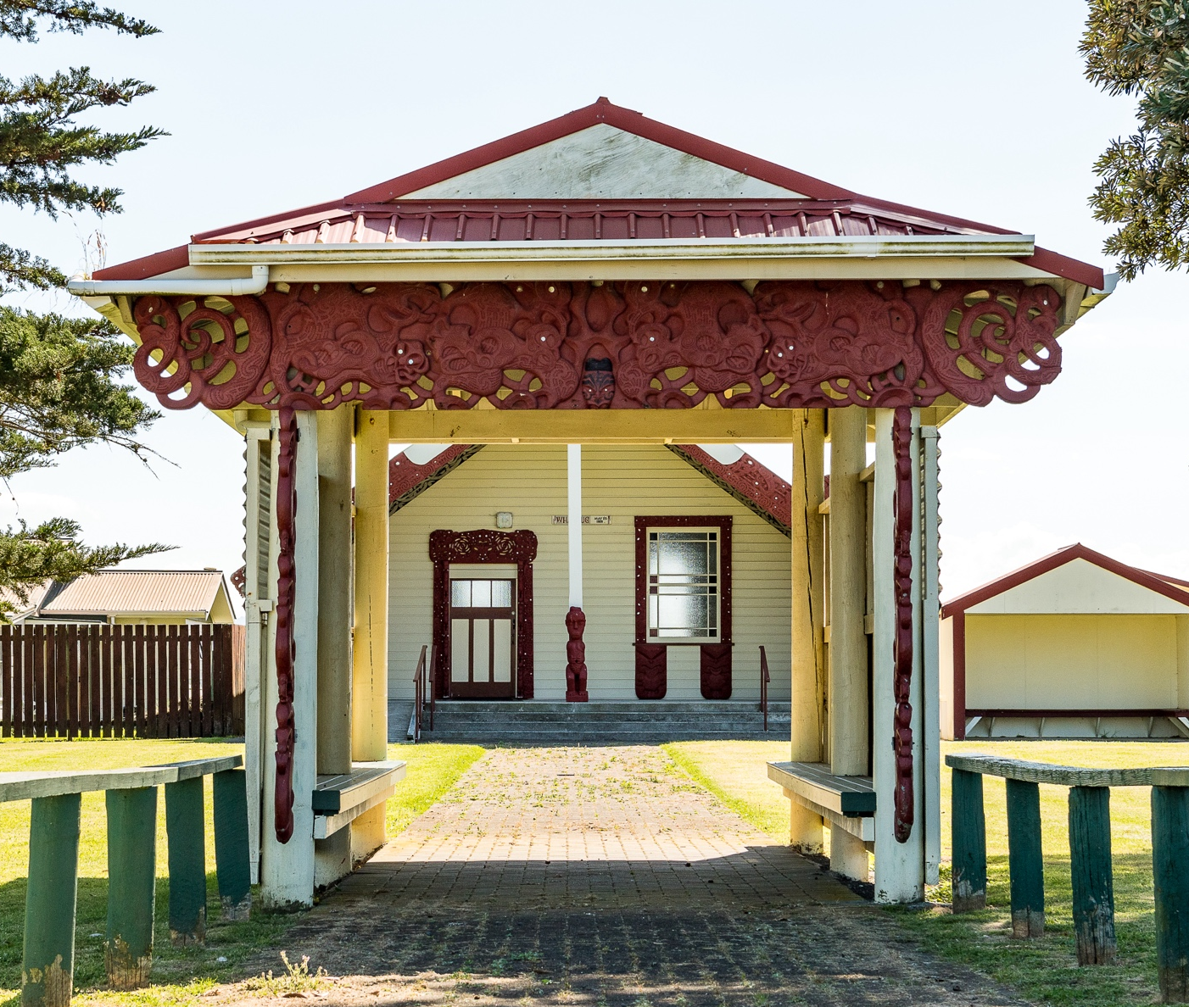

Tangata Whenua refers to Māori.

